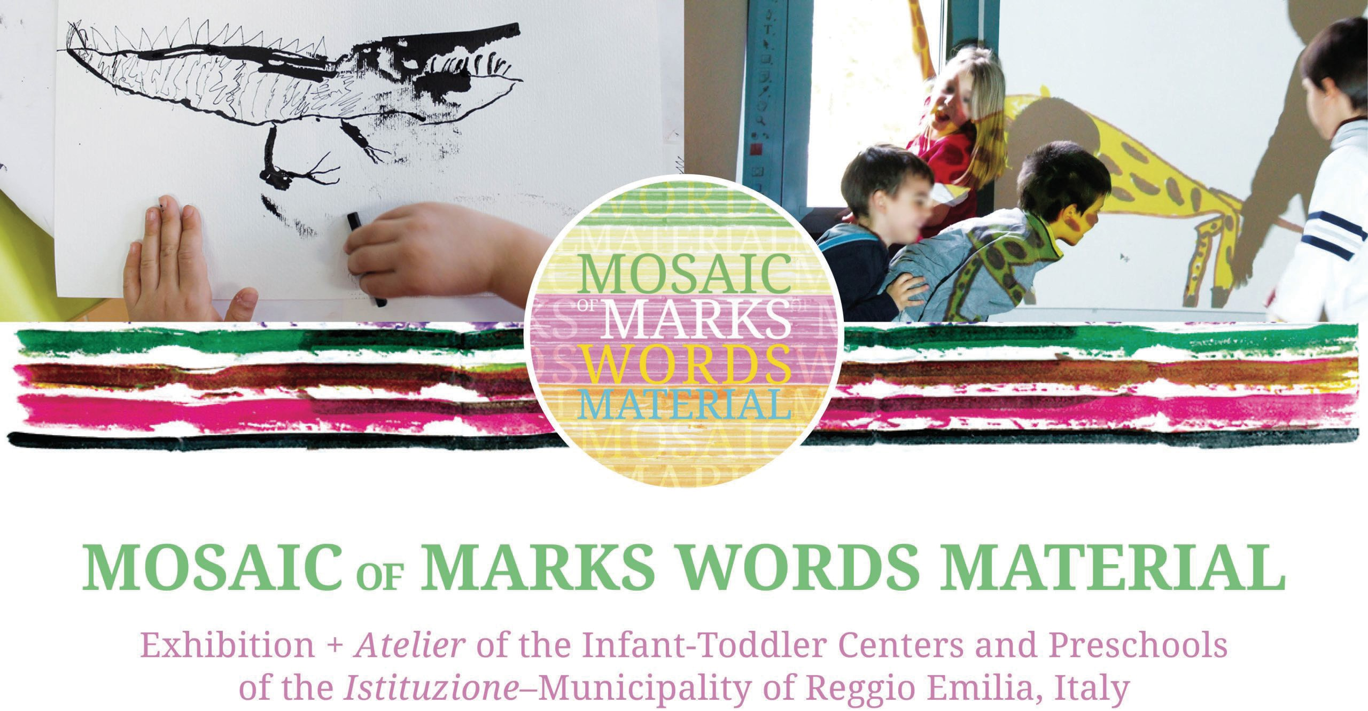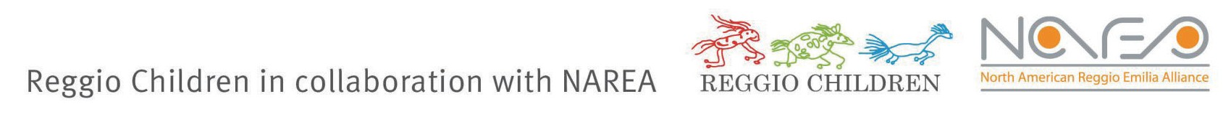
www.reggiochildren.it/en/rc/exhibitions/mosaic-of-marks-words-material/

joy.

wonder. love.
Please join us in celebrating children and teachers with a gift of joy, wonder & love!

a gift of joy
The exhibition-atelier Mosaic of Marks, Words, Material will welcome hundreds of Early Childhood educators, families, and policymakers over the summer of 2026 at the Winooski Educational Center.

a gift of wonder
The atelier, or studio, will be a special place where children will encounter carefully selected art materials to explore, create, and tell their stories.
It will also serve as a resource for Early Childhood educators to consider multiple learning possibilities these materials offer.

a gift of Love
We need your support!
Please consider becoming a sponsor of this extraordinary exhibition-atelier Mosaic of Marks, Words Material from the world-famous municipal Early Childhood programs of Reggio Emilia, Italy.

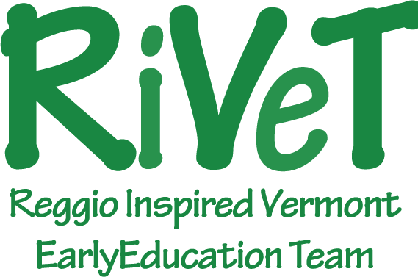
aBOUT uS
RIVET is a network of Vermont Early Childhood educators. For more information about the exhibition-atelier and other RIVET initiatives, please visit www.rivetnetwork.net.

sponsorship
opportunities

SPONSOR LEVELS & BENEFITS

Recognition at opening ceremony
starlight
$5000
starbright
$3000
first star
$1000
wish i may
$250
wish I might

mention in all press releases

Logo on promotional materials

Logo on website

tickets to exhibit preview gala invitation to exhibit opening acknowledgement in program

4 tickets

2 tickets

1 ticket

name on website







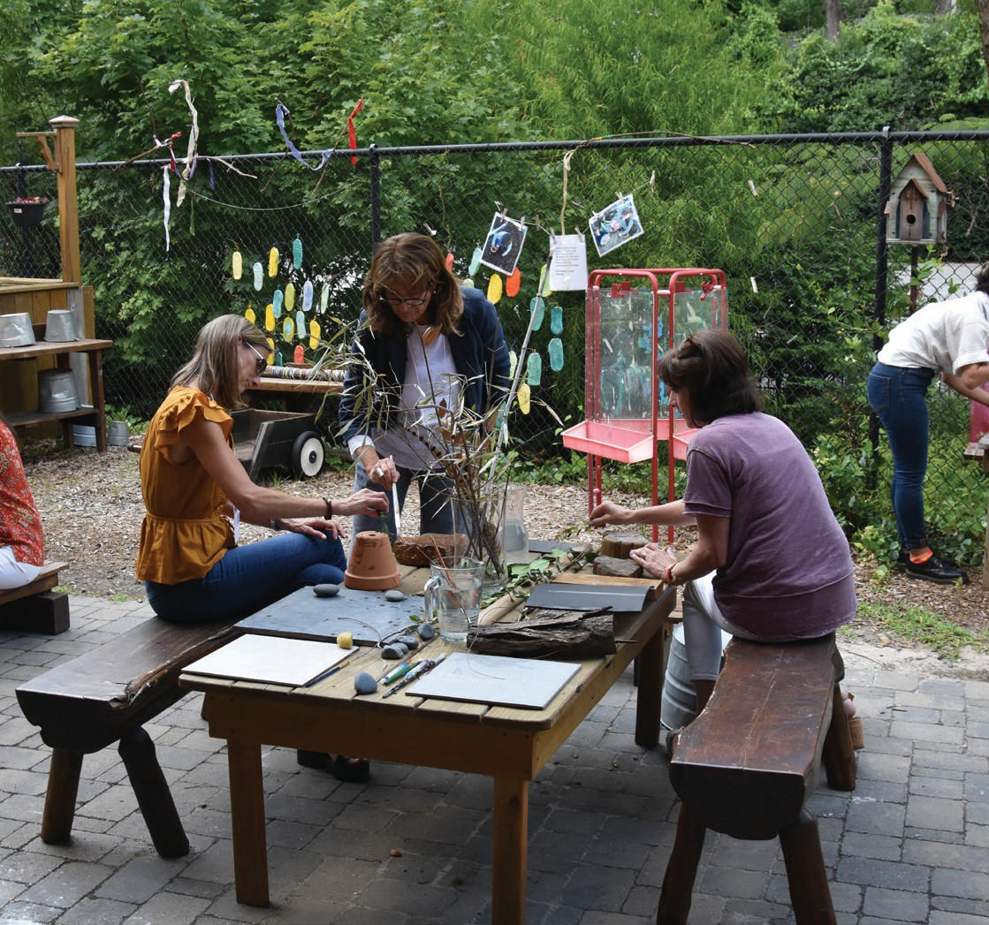
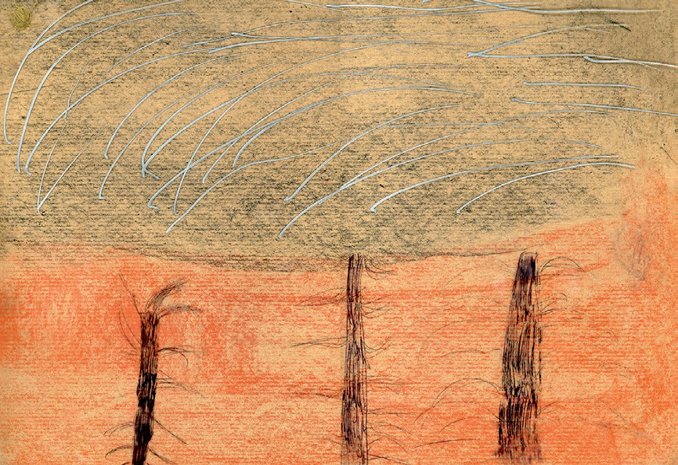
contact us
Jeanne Goldhaber 802-310-7637
rivetvermont@gmail.com www.rivetnetwork.net
We welcome all levels of support, including in-kind contributions! Contact us to discuss creating a custom sponsorship package.

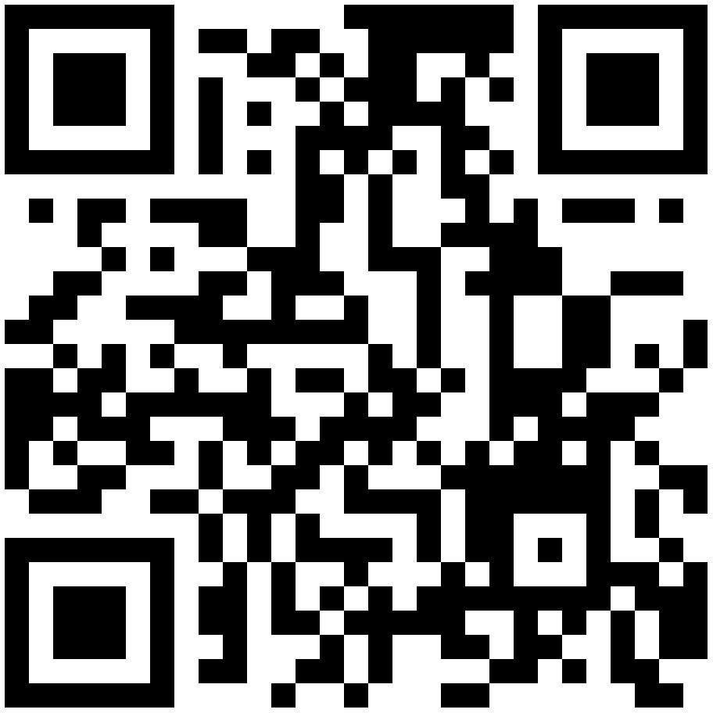
Scan here to donate directly!

